**College Record Management System**

**1. Introduction**

The College Record Management System is designed to handle the administrative tasks of maintaining records for students, faculty, and courses. This system simplifies the process of managing data and enhances the efficiency of administrative operations in educational institutions.

**Additional Sections:**

**Problem Statement**

The current manual system for managing college records is time-consuming and prone to errors. The need for an automated system to streamline administrative tasks and improve data accuracy and accessibility is essential.

**Scope**

The project aims to develop a comprehensive system to manage student, faculty, and course records, generate reports, and ensure data security.

**Objectives**

* To automate the record-keeping process for students, faculty, and courses
* To provide quick and easy access to records
* To reduce administrative overhead and errors

**2. Requirements**

**2.1 Hardware Requirements**

* Processor: Intel Core i3 or higher
* RAM: 4 GB or more
* Hard Disk: 500 GB or more
* Monitor: 15” color monitor
* Keyboard and Mouse

**2.2 Software Requirements**

* Operating System: Windows 10 or higher / Linux
* Development Environment: Visual Studio / Code::Blocks / GCC
* C++ Compiler
* Database: MySQL / SQLite

**2.3 Functional Requirements**

* Add, update, and delete student records
* Add, update, and delete faculty records
* Add, update, and delete course records
* View all records
* Search for specific records

**3. Diagrams**

**3.1 Use Case Diagram**

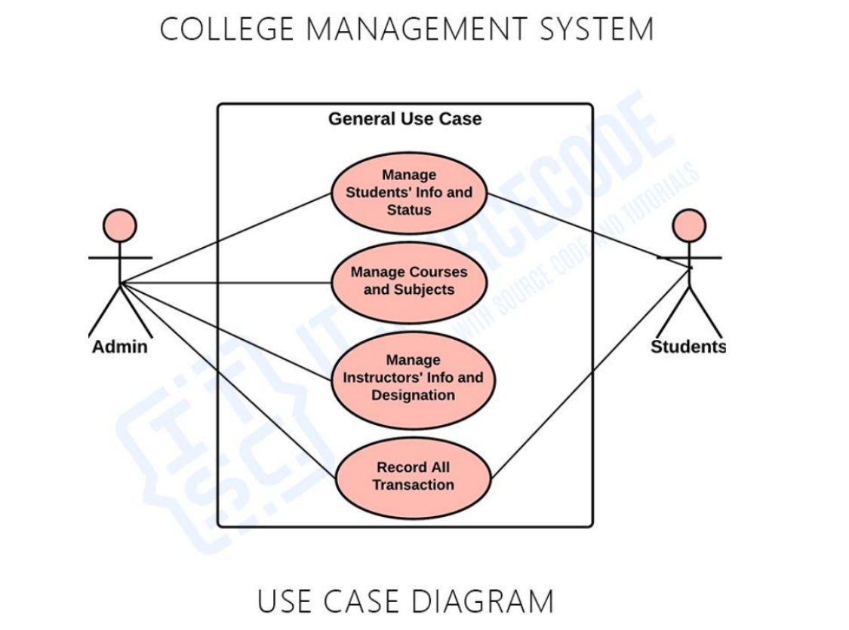

**3.2 Modular Diagram**

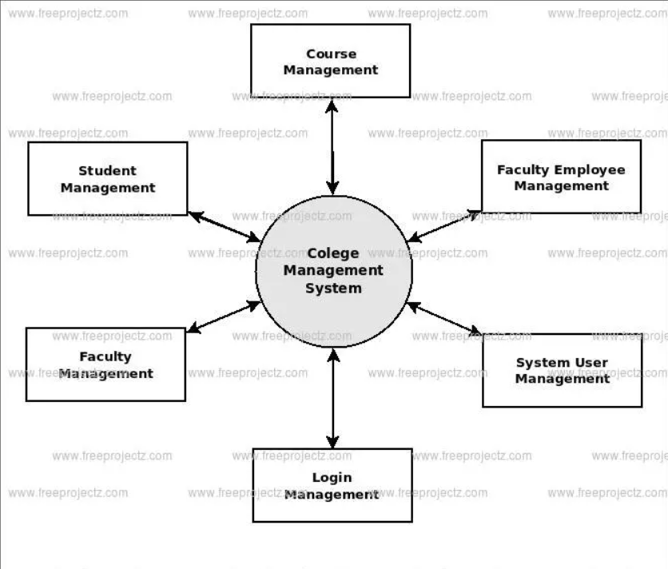

**3.3 Activity Diagram**

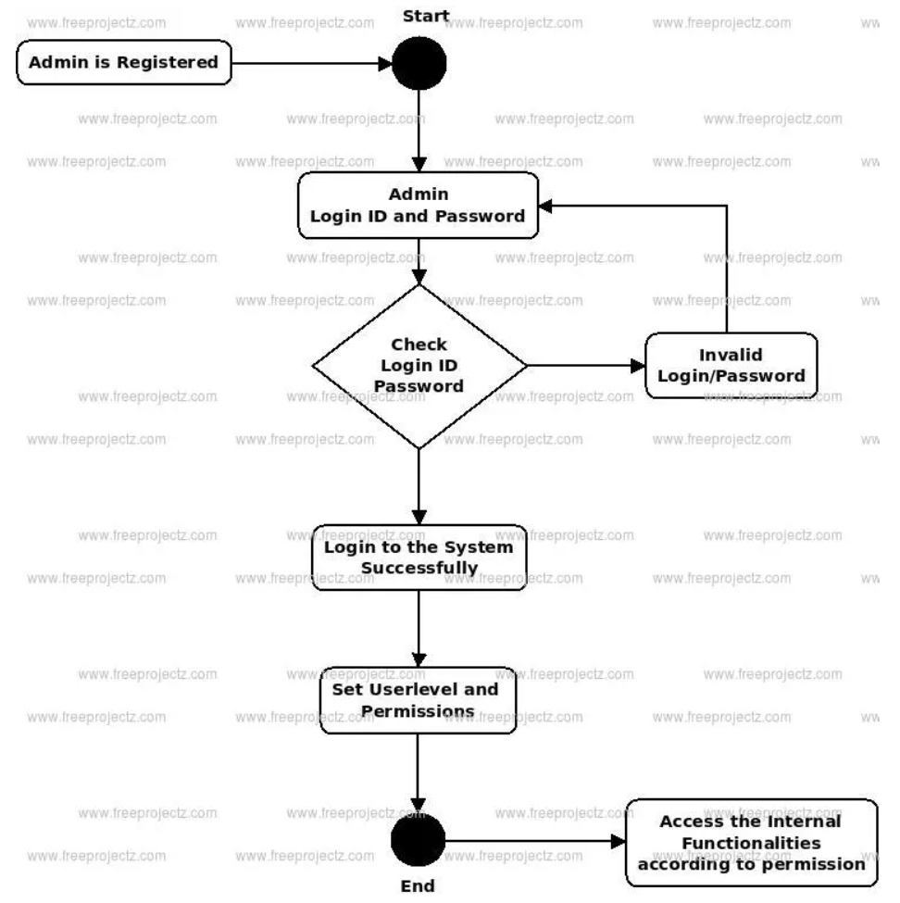

**4. Design / Interface**

* **Login Screen**: Interface for user authentication
* **Main Menu**: Options for managing students, faculty, and courses
* **Student Management**: Form to add/update/delete student records
* **Faculty Management**: Form to add/update/delete faculty records
* **Course Management**: Form to add/update/delete course records
* **Report Generation**: Interface to generate and view reports

**5. Implementation**

// Sample code for adding a student record

#include <iostream>

#include <vector>

#include <string>

using namespace std;

class Student {

public:

int id;

string name;

string department;

string year;

Student(int id, string name, string department, string year) {

this->id = id;

this->name = name;

this->department = department;

this->year = year;

}

};

vector<Student> students;

const int MAX_STUDENTS = 2;

void addStudent(int id, string name, string department, string year) {

if (students.size() >= MAX_STUDENTS) {

cout << "Cannot add more students. Maximum limit reached!" << endl;

return;

}

Student newStudent(id, name, department, year);

students.push_back(newStudent);

cout << "Student added successfully!" << endl;

}

void deleteStudent(int id) {

for (auto it = students.begin(); it != students.end(); ++it) {

if (it->id == id) {

students.erase(it);

cout << "Student with ID " << id << " deleted successfully!" << endl;

return;

}

}

cout << "Student with ID " << id << " not found." << endl;

}

void viewStudents() {

if (students.empty()) {

cout << "No students found." << endl;

return;

}

for (const Student& s : students) {

cout << "ID: " << s.id << ", Name: " << s.name << ", Department: " << s.department << ", Year: " << s.year << endl;

}

}

int main() {

int choice, id;

string name, department, year;

while (true) {

cout << "\n1. Add Student\n2. Delete Student\n3. View Students\n4. Exit\n";

cout << "Enter your choice: ";

cin >> choice;

switch (choice) {

case 1:

cout << "Enter ID: ";

cin >> id;

cout << "Enter Name: ";

cin.ignore();

getline(cin, name);

cout << "Enter Department: ";

getline(cin, department);

cout << "Enter Year: ";

getline(cin, year);

addStudent(id, name, department, year);

break;

case 2:

cout << "Enter ID of student to delete: ";

cin >> id;

deleteStudent(id);

break;

case 3:

viewStudents();

break;

case 4:

return 0;

default:

cout << "Invalid choice. Please try again." << endl;

}

}

}

**6. Output**

**Sample Output for Adding and Displaying Students**

**1. Add Student**

**2. Delete Student**

**3. View Students**

**4. Exit**

**Enter your choice: 1**

**Enter ID: 1**

**Enter Name: John Doe**

**Enter Department: Computer Science**

**Enter Year: 2nd Year**

**Student added successfully!**

**1. Add Student**

**2. Delete Student**

**3. View Students**

**4. Exit**

**Enter your choice: 1**

**Enter ID: 2**

**Enter Name: Jane Smith**

**Enter Department: Electrical Engineering**

**Enter Year: 3rd Year**

**Student added successfully!**

**1. Add Student**

**2. Delete Student**

**3. View Students**

**4. Exit**

**Enter your choice: 1**

**Enter ID: 3**

**Enter Name: Alice Johnson**

**Enter Department: Mechanical Engineering**

**Enter Year: 1st Year**

**Cannot add more students. Maximum limit reached!**

**1. Add Student**

**2. Delete Student**

**3. View Students**

**4. Exit**

**Enter your choice: 3**

**ID: 1, Name: John Doe, Department: Computer Science, Year: 2nd Year**

**ID: 2, Name: Jane Smith, Department: Electrical Engineering, Year: 3rd Year**

**1. Add Student**

**2. Delete Student**

**3. View Students**

**4. Exit**

**Enter your choice: 2**

**Enter ID of student to delete: 1**

**Student with ID 1 deleted successfully!**

**1. Add Student**

**2. Delete Student**

**3. View Students**

**4. Exit**

**Enter your choice: 3**

**ID: 2, Name: Jane Smith, Department: Electrical Engineering, Year: 3rd Year**

**1. Add Student**

**2. Delete Student**

**3. View Students**

**4. Exit**

**Enter your choice: 4**

**7. Conclusion**

The College Record Management System developed in C++ is a robust and efficient tool for managing student, faculty, and course records. It streamlines the administrative processes and enhances data accessibility and integrity.

**8. References**

* C++ Programming: Principles and Practice by Bjarne Stroustrup
* College administration documentation
* Online tutorials and resources